**Create Login Form Using jQuery**



Neeraj Agarwal

This tutorial concerns about creating a login form and validating it using  jQuery. The prestored  username, password are verified from database whether both exist’s or not in our database, this is done using PHP script .

Here we have created a simple HTML form with two fields- Email and Password. jQuery validation is used for email and password to ensure that they are valid or not .

You can download the zip file or simply follow our code and edit it to use.

**-:See Also:-**

[**jQuery Registration Form**](https://www.formget.com/jquery-registration-form/)

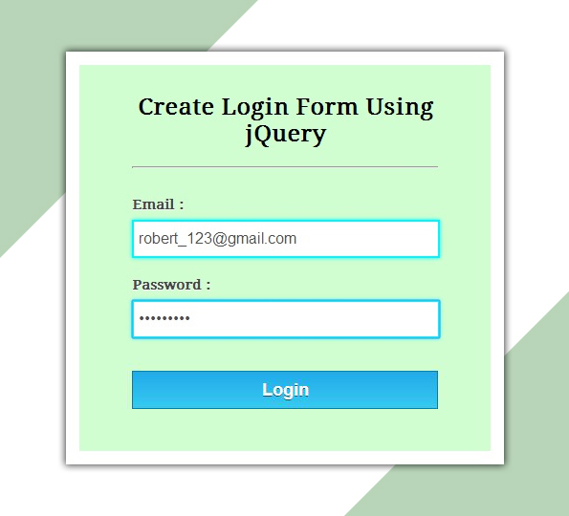

[DOWNLOAD SCRIPT](javascript:void(0))

**HTML File: login.html**

Given below our complete HTML code , copy to use it.

**<!DOCTYPE html>**

**<html>**

**<head>**

**<title>Login Form Using jQuery - Demo Preview</title>**

**<meta name="robots" content="noindex, nofollow">**

**<!-- Include CSS File Here -->**

**<link rel="stylesheet" href="css/style.css"/>**

**<!-- Include CSS File Here -->**

**<script src="http://ajax.googleapis.com/ajax/libs/jquery/1.11.1/jquery.min.js"></script>**

**<script type="text/javascript" src="js/login.js"></script>**

**</head>**

**<body>**

**<div class="container">**

**<div class="main">**

**<form class="form" method="post" action="#">**

**<h2>Create Login Form Using jQuery</h2>**

**<label>Email :</label>**

**<input type="text" name="demail" id="email">**

**<label>Password :</label>**

**<input type="password" name="password" id="password">**

**<input type="button" name="login" id="login" value="Login">**

**</form>**

**</div>**

**</div>**

**</body>**

**</html>**

**jQuery File:  login.js**

Given below our complete jQuery code.

**$(document).ready(function(){**

**$("#login").click(function(){**

**var email = $("#email").val();**

**var password = $("#password").val();**

**// Checking for blank fields.**

**if( email =='' || password ==''){**

**$('input[type="text"],input[type="password"]').css("border","2px solid red");**

**$('input[type="text"],input[type="password"]').css("box-shadow","0 0 3px red");**

**alert("Please fill all fields...!!!!!!");**

**}else {**

**$.post("login.php",{ email1: email, password1:password},**

**function(data) {**

**if(data=='Invalid Email.......') {**

**$('input[type="text"]').css({"border":"2px solid red","box-shadow":"0 0 3px red"});**

**$('input[type="password"]').css({"border":"2px solid #00F5FF","box-shadow":"0 0 5px #00F5FF"});**

**alert(data);**

**}else if(data=='Email or Password is wrong...!!!!'){**

**$('input[type="text"],input[type="password"]').css({"border":"2px solid red","box-shadow":"0 0 3px red"});**

**alert(data);**

**} else if(data=='Successfully Logged in...'){**

**$("form")[0].reset();**

**$('input[type="text"],input[type="password"]').css({"border":"2px solid #00F5FF","box-shadow":"0 0 5px #00F5FF"});**

**alert(data);**

**} else{**

**alert(data);**

**}**

**});**

**}**

**});**

**});**

**PHP Script: login.php**

Below script executes for matching email and password in database.

**<?php**

**$connection = mysql_connect("localhost", "root", ""); // Establishing connection with server..**

**$db = mysql_select_db("college", $connection); // Selecting Database.**

**$email=$_POST['email1']; // Fetching Values from URL.**

**$password= sha1($_POST['password1']); // Password Encryption, If you like you can also leave sha1.**

**// check if e-mail address syntax is valid or not**

**$email = filter_var($email, FILTER_SANITIZE_EMAIL); // sanitizing email(Remove unexpected symbol like <,>,?,#,!, etc.)**

**if (!filter_var($email, FILTER_VALIDATE_EMAIL)){**

**echo "Invalid Email.......";**

**}else{**

**// Matching user input email and password with stored email and password in database.**

**$result = mysql_query("SELECT * FROM registration WHERE email='$email' AND password='$password'");**

**$data = mysql_num_rows($result);**

**if($data==1){**

**echo "Successfully Logged in...";**

**}else{**

**echo "Email or Password is wrong...!!!!";**

**}**

**}**

**mysql_close ($connection); // Connection Closed.**

**?>**

**CSS File: style.css**

Styling HTML Elements.

**/* Below line is used for online Google font */**

**@import url(http://fonts.googleapis.com/css?family=Droid+Serif);**

**h2{**

**text-align: center;**

**font-size: 24px;**

**}**

**hr{**

**margin-bottom: 30px;**

**}**

**div.container{**

**width: 960px;**

**height: 610px;**

**margin:50px auto;**

**font-family: 'Droid Serif', serif;**

**position:relative;**

**}**

**div.main{**

**width: 320px;**

**margin-top: 80px;**

**float:left;**

**padding: 10px 55px 40px;**

**background-color: rgba(187, 255, 184, 0.65);**

**border: 15px solid white;**

**box-shadow: 0 0 10px;**

**border-radius: 2px;**

**font-size: 13px;**

**}**

**input[type=text],[type=password] {**

**width: 97.7%;**

**height: 34px;**

**padding-left: 5px;**

**margin-bottom: 20px;**

**margin-top: 8px;**

**box-shadow: 0 0 5px #00F5FF;**

**border: 2px solid #00F5FF;**

**color: #4f4f4f;**

**font-size: 16px;**

**}**

**label{**

**color: #464646;**

**text-shadow: 0 1px 0 #fff;**

**font-size: 14px;**

**font-weight: bold;**

**}**

**#login {**

**width: 100%;**

**background: linear-gradient(#22abe9 5%, #36caf0 100%);**

**border: 1px solid #0F799E;**

**font-size: 20px;**

**margin-top: 15px;**

**padding: 8px;**

**font-weight: bold;**

**cursor: pointer;**

**color: white;**

**text-shadow: 0px 1px 0px #13506D;**

**}**

**#login:hover{**

**background: linear-gradient(#36caf0 5%, #22abe9 100%);**

**}**

**Conclusion:**

This was all about creating simple login form with validation and database connectivity.  Hope you have liked it, keep reading our other blogs for getting attached with more coding tricks.